**RAJALAKSHMI ENGINEERING COLLEGE**

**RAJALAKSHMI NAGAR, THANDALAM – 602 105**



|  |
| --- |
| **CS23A34**  **USER INTERFACE AND DESIGN LAB** |
| **Laboratory Observation Notebook** |

|  |
| --- |
| **Name :** Subash Krishnan A  **Year/Branch/Section :** II/CSE/D  **Register No. :** 230701345  **Semester :** IV  **Academic Year:** 2024-25 |

**Ex. No.: 2**

**Register No.: 230701345**   **Name: Subash Krishnan A**



**Memory Chunking**

**Aim:**

To design a UI where users recall visual elements (e.g., icons or text chunks) and to evaluate the effect of chunking on user memory.

**Procedure:**

**A. Home Screen (It contains Instruction Page)**

Step 1: Create a Frame:

o In Figma, create a new frame (File → New Frame). Set the size to 1024x768px for a standard desktop view.

o This will be your Home Screen where users start the task.

Step 2: Add Instructions:

o Use the Text Tool (T) to add a heading like “Memory Recall Task.”

o Add a smaller body of text with instructions such as:

“You will be shown several groups of icons or text. After viewing, recall the items you remember.”

o Use the Text Tool (T) to add more detailed instructions like “You will have 5 seconds to view the items. Then, recall them in the next screen.”

Step 3: Start Button:

o Create a button at the bottom of the screen. To do this:

▪ Draw a Rectangle (R) for the button.

▪ Use the Text Tool (T) to add “Start.”

▪ Style the button (colour, border radius) to make it stand out.

▪ Use Figma’s Prototyping Tools (top bar → Prototype) to link this

button to the next screen (Chunking Phase).

▪ You can also use interactive components like hover effects for more

realism.

**B. Chunking Phase (It Display Chunked Items)**

Step 1: Create a New Frame:

o Create a new frame for the Chunking Phase (the second screen). This frame will display the icons or text.

Step 2: Design Chunked Items:

o Use icons or text blocks that users will have to recall. If you are using text, it could be short phrases or words. If you are using icons, you can either import them from Figma’s resources or draw simple shapes using Figma’s drawing tools.

o For Chunking with Borders:

▪ Group 3-5 icons or text together in a box (use the Rectangle Tool (R))

to visually represent a chunk. You might want to create 3-4 groups.

▪ Space these chunks out with some empty space in between them to

ensure users can identify each chunk.

o For Chunking without Borders:

▪ Place the elements next to each other without clear separation. This

can be done by not using boxes and just visually mixing the items.

Step 3: Set the Viewing Time:

o Time Simulation: Figma does not have true timers, but you can simulate a

fixed time by setting the next screen transition after 5 seconds:

▪ Select the entire Frame (Chunking Phase).

▪ Under the Prototype tab, link this frame to the next screen (Recall

Phase).

▪ Set the interaction to “After Delay” and enter 5000ms (5 seconds).

**C. Recall Phase**

Step 1: Create a New Frame for Recall:

o This is where the user will recall the items they saw in the previous chunking

phase.

Step 2: Recall Input (Multiple-choice or Text Input):

o Option 1: Multiple-Choice:

▪ Create multiple options for the user to select (e.g., 4-5 icons or text

options).

▪ Use Checkboxes or Radio buttons to allow users to select what they

remember.

▪ Add a question at the top: “Select the items you remember seeing.”

o Option 2: Text Input:

▪ Create Text Input Fields where users can type what they remember.

Create 3-5 input fields depending on how many chunks you showed.

▪ This can be done by selecting the Text Tool (T), adding a label “Item1”, “Item 2”), and setting up input boxes.

Step 3: Submit Button:

o Create a Submit button at the bottom using the Rectangle Tool (R) and

adding text like “Submit Recall."

o Add an interaction to move to the Feedback Screen after submission.

**D. Result Screen**

1. Create a Feedback Screen:  
o After the user submits their recall, provide feedback.  
o Add text like: “You recalled 4/5 items correctly!” or “Good job, you remembered 3 out of 5 items.”

2. Analyse:

o For your experiment, you can vary the chunk size (3 vs. 5 items per chunk) and the chunk type (icons vs. text) across different test sessions to evaluate their impact on recall.

**Output:**   
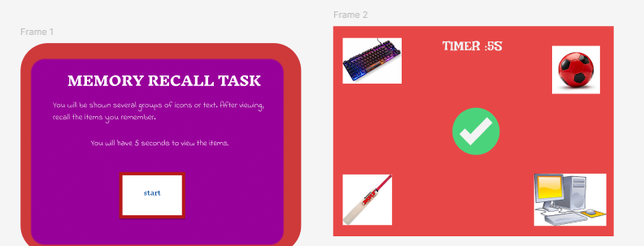

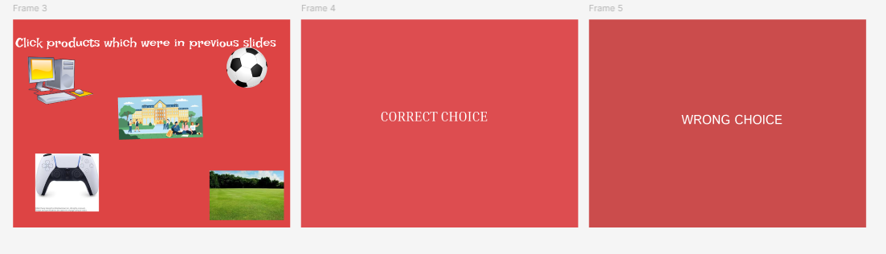

**Result:**  
 Hence the introduction to Figma with good and bad design has been successfully studied and executed.